fResponse to the Reviewers’ Comments for TIA-2026-IPCC-0540
Manuscript Title: Design and Implementation of a Non-coupled Integrated Transformer for a Two-phase Interleaved Flyback PFC Rectifier

Oct 26, 2026

Dear Editor,

We would like to express our sincere appreciation to the reviewers for their constructive and insightful comments on our manuscript. The manuscript was revised in accordance with point-by-point answers to all the questions and suggestions.
- We thank the reviewer for going through and agreeing with our response letter.
- Pages xx to xx correspond to Reviewer #2’s comments.
- Pages xx to xx correspond to Reviewer #3’s comments.
We revised the manuscript accordingly to the reviewers comments. In particular, we strengthened the literature review, clarified various explanations on the operational principle of the transformer, insights on the operation compared to a conventional, discrete implementation, and provided clarification on the experimental environment. We also updated the manuscript to improve clarity, consistency, and minor errors.

We hope the manuscript is now acceptable for publication.

Best Regards,
Sihoon Choi
Corresponding author,
Institute of Materials and Systems for Sustainability, Nagoya University
Email: choi.sihoon.w4@f.mail.nagoya-u.ac.jp

To Reviewer 2
We authors appreciate your valuable comments. The revised parts are indicated by red texts in the manuscript.
Comments to the Author
1.The analytical explanation of the inherent DCM PFC mechanism is now clearer. However, the experimental verification remains insufficient. Please report measured PF and input-current THD, preferably at representative operating points.
->I think we cannot do experiment again. Let’s emphasize that the whole mechanism is the same with the conventional topology, and show it by simulation. Please present PF and THD comparison by simulation.

2.The added time-domain analysis satisfactorily explains the variation over one line cycle. Nevertheless, the manuscript should also clarify the variation of peak switch current and peak flux density when the RMS input voltage changes from 100 to 240 V, including the corresponding duty-cycle adjustment. Please identify the actual worst-case operating condition for switch current and core flux density.
We completely agree that clarifying the component stresses across the universal input voltage range (100 V to 240 V) provides a more comprehensive understanding of the converter's design limits.
To address the variation in peak switch current and peak flux density, we must look at how the constant duty cycle $D$ adjusts with the RMS input voltage. In a DCM flyback PFC, to deliver a constant output power $P_{o}$, the duty cycle is inversely proportional to the peak input voltage $V_{in_{max}}$, governed by:
$$D=\frac{2}{V_{in_{max}}}\sqrt{\frac{0.5L_{m}P_{o}}{T_{s}}}$$
When the RMS input voltage increases from 100 V to 240 V, the control loop naturally decreases $D$ to maintain the same power transfer. If we substitute this adjusted duty cycle into the absolute maximum peak switch current equation (which occurs at the peak of the AC line cycle), we get:
$$I_{S_{pk\left(max\right)}}=\frac{V_{in_{max}}}{L_{m}}DT_{s}=\frac{V_{in_{max}}}{L_{m}}\left(\frac{2}{V_{in_{max}}}\sqrt{\frac{0.5L_{m}P_{o}}{T_{s}}}\right)T_{s}=2\sqrt{\frac{0.5P_{o}T_{s}}{L_{m}}}$$
As shown, the $V_{in_{max}}$ term mathematically cancels out. This demonstrates that for a fixed output power, the absolute peak switch current and the peak core flux density remain theoretically constant across the entire 100 V to 240 V input range.
However, the worst-case operating condition for the current and the magnetic core is still the lowest input voltage ($100$ ${\text{V}}_{\text{rms}}$). While the peak current remains constant, the duration of the current pulse (the duty cycle $D$) reaches its absolute maximum at 100 ${\text{V}}_{\text{rms}}$. Consequently, the RMS currents in the switches and transformer windings are maximized at 100 ${\text{V}}_{\text{rms}}$, leading to the highest conduction losses and thermal stresses. Factoring in the practical drop in efficiency at lower line voltages, the peak current will be slightly higher at 100 ${\text{V}}_{\text{rms}}$ to compensate for these losses, cementing it as the worst-case condition for current stress and core saturation. Conversely, the highest input voltage ($240$ ${\text{V}}_{\text{rms}}$) is the worst-case condition for the switch voltage stress ($V_{ds_{max}}$).
We have added a new paragraph to the end of Section II-A to explicitly clarify this dynamic across the universal input voltage range and clearly identify the worst-case conditions for the readers.

3.The expanded literature survey is appreciated. However, the requested comprehensive comparison would be considerably clearer in tabulated form.
Configuration | Transformer Type | Key Advantages | Drawbacks/  Limitations
Conventional Interleaved | Multiple, discrete cores | Independent phase operation, simple control | High component count, low power density, and increased footprint
Coupled Interleaved | Integrated (coupled) | High power density, potential ripple reduction | Circulating currents, higher parasitics, and complex control
Decoupled Interleaved | Integrated (Orthogonal/Custom Core Geometry) | Independent phase operation, high power density | High manufacturing complexity
Proposed Topology | Integrated (Non-coupled) | Independent operation, high power density, uses standard commercial EE-core

4. Although the quality of the experimental waveforms has improved, the waveform traces should be thickened further to enhance visibility and readability.
Thank you for your comments. We agree that the experimental waveforms needed more improvement. We thickened the waveforms and improved contrast further as follows. Please do let us know if the waveforms need further improvement.

Before revision | After revision
(in Section V, Fig. 17)  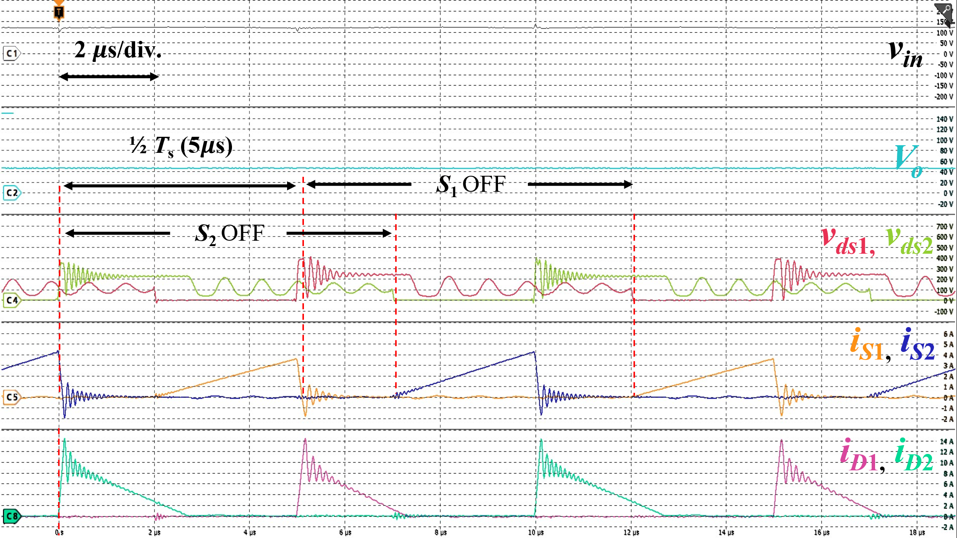  (b)  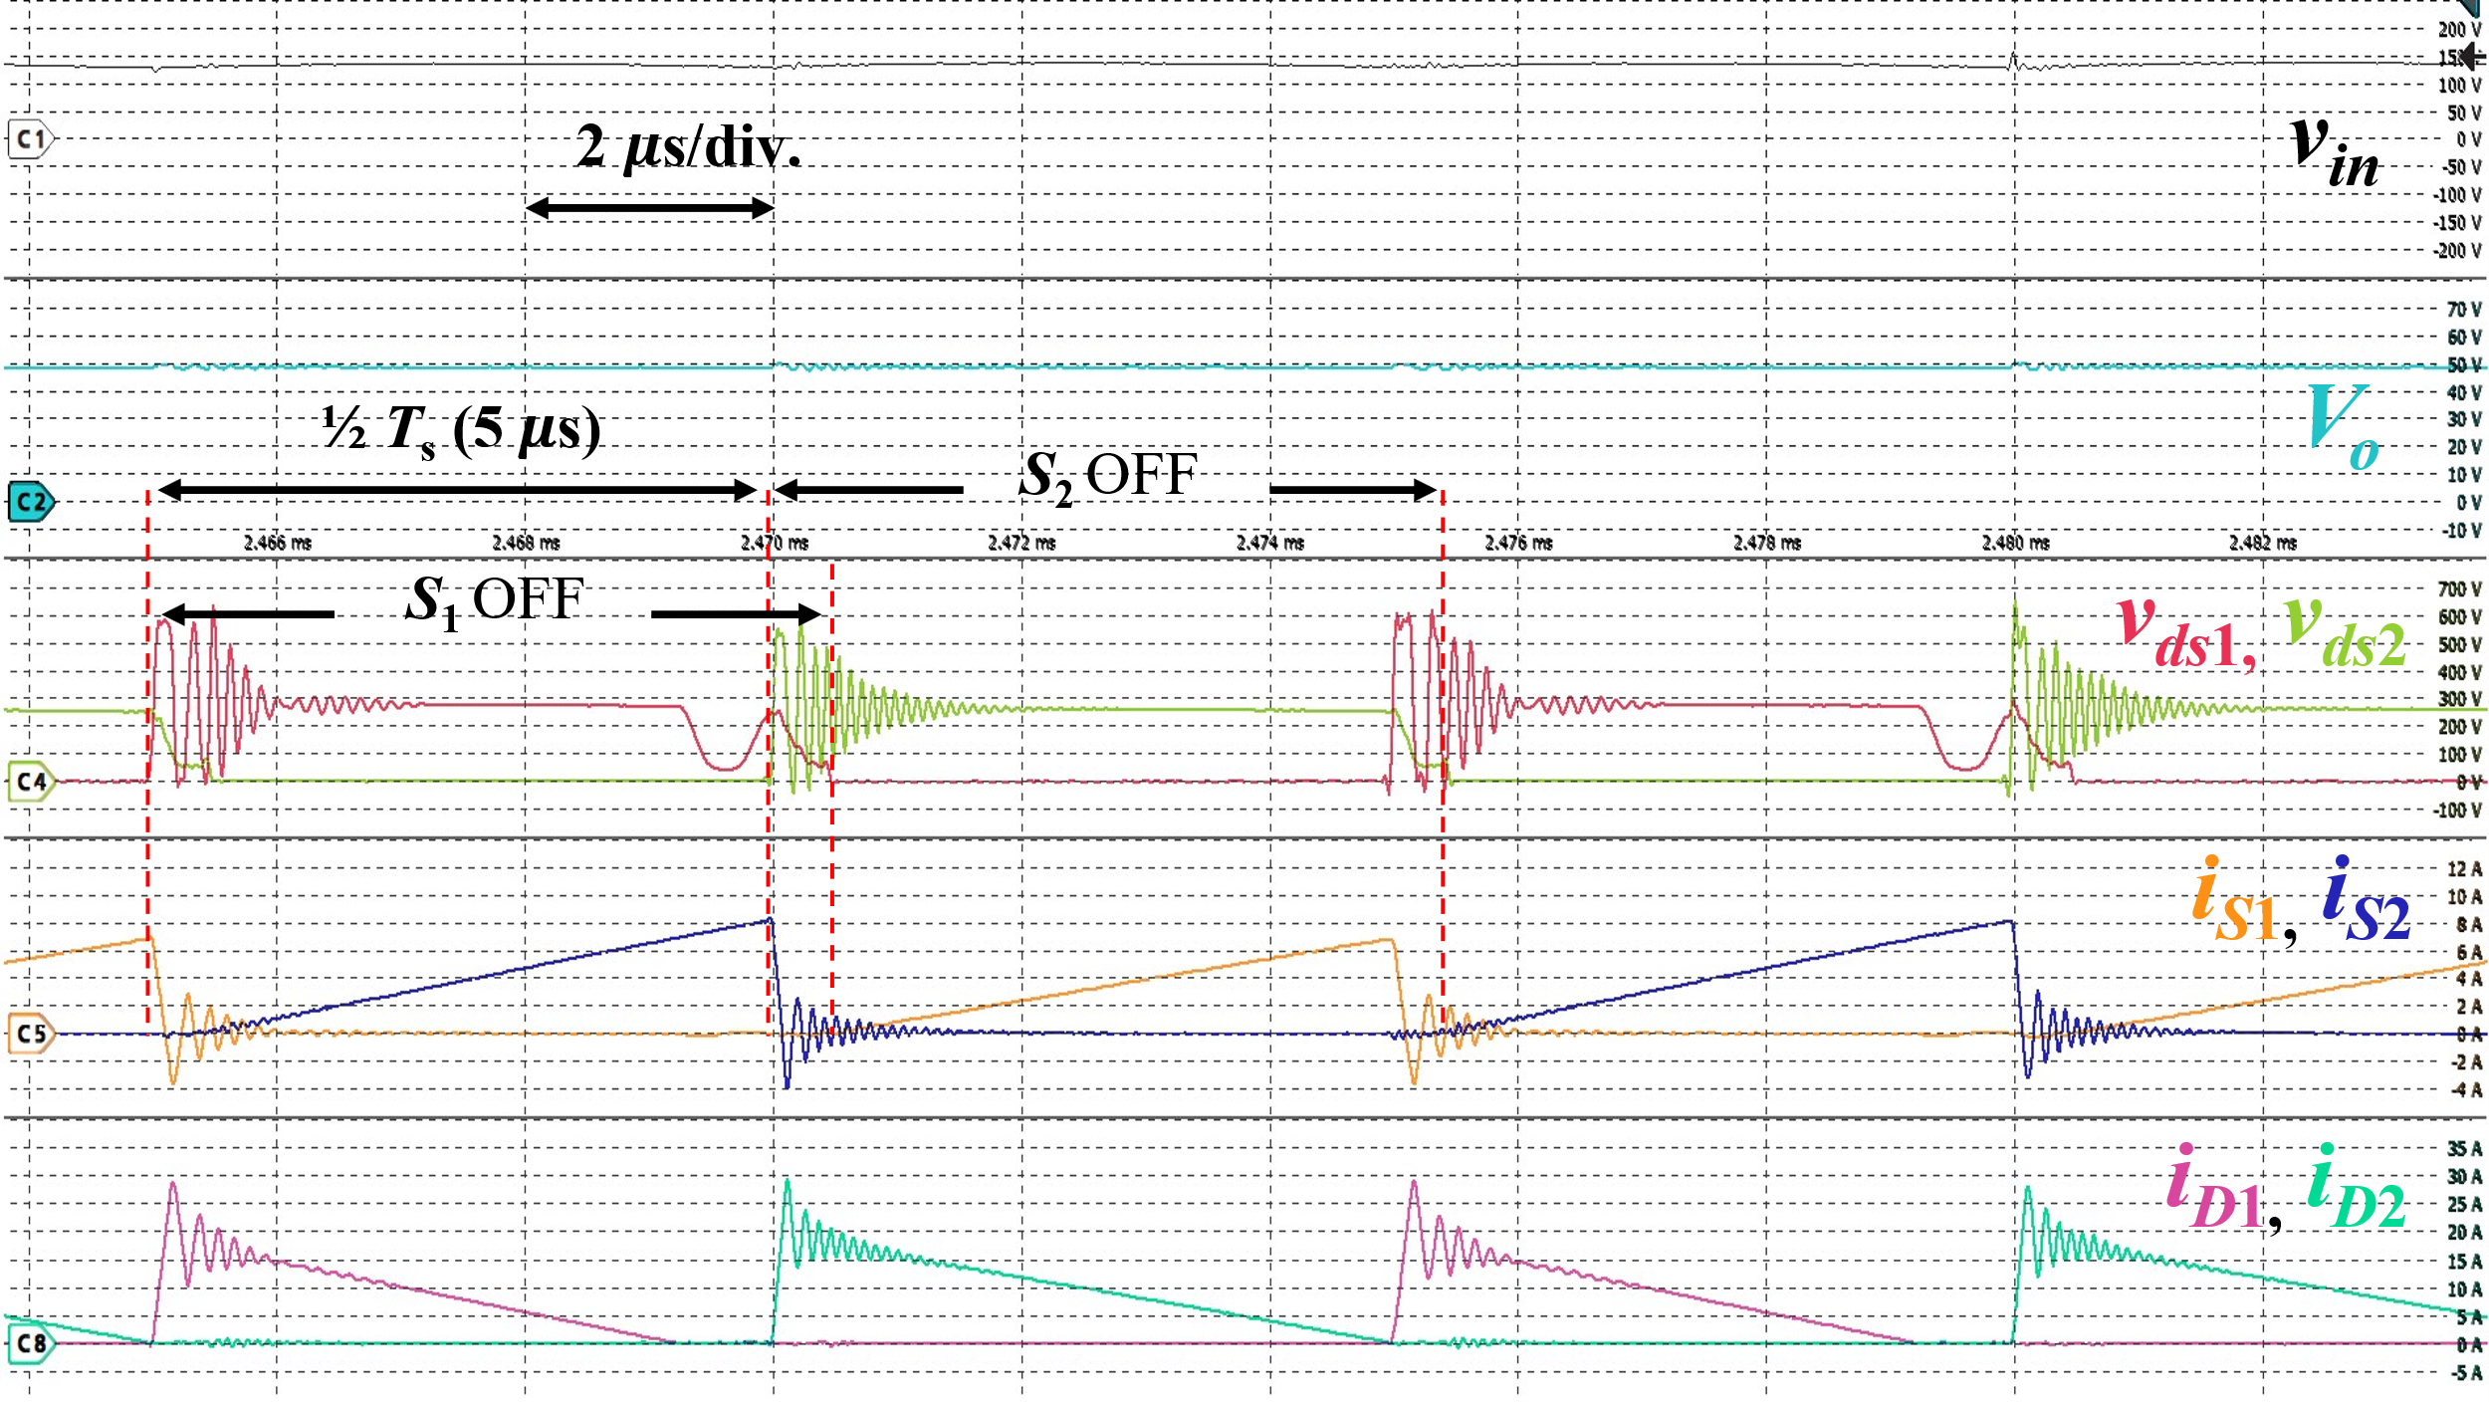  (c)  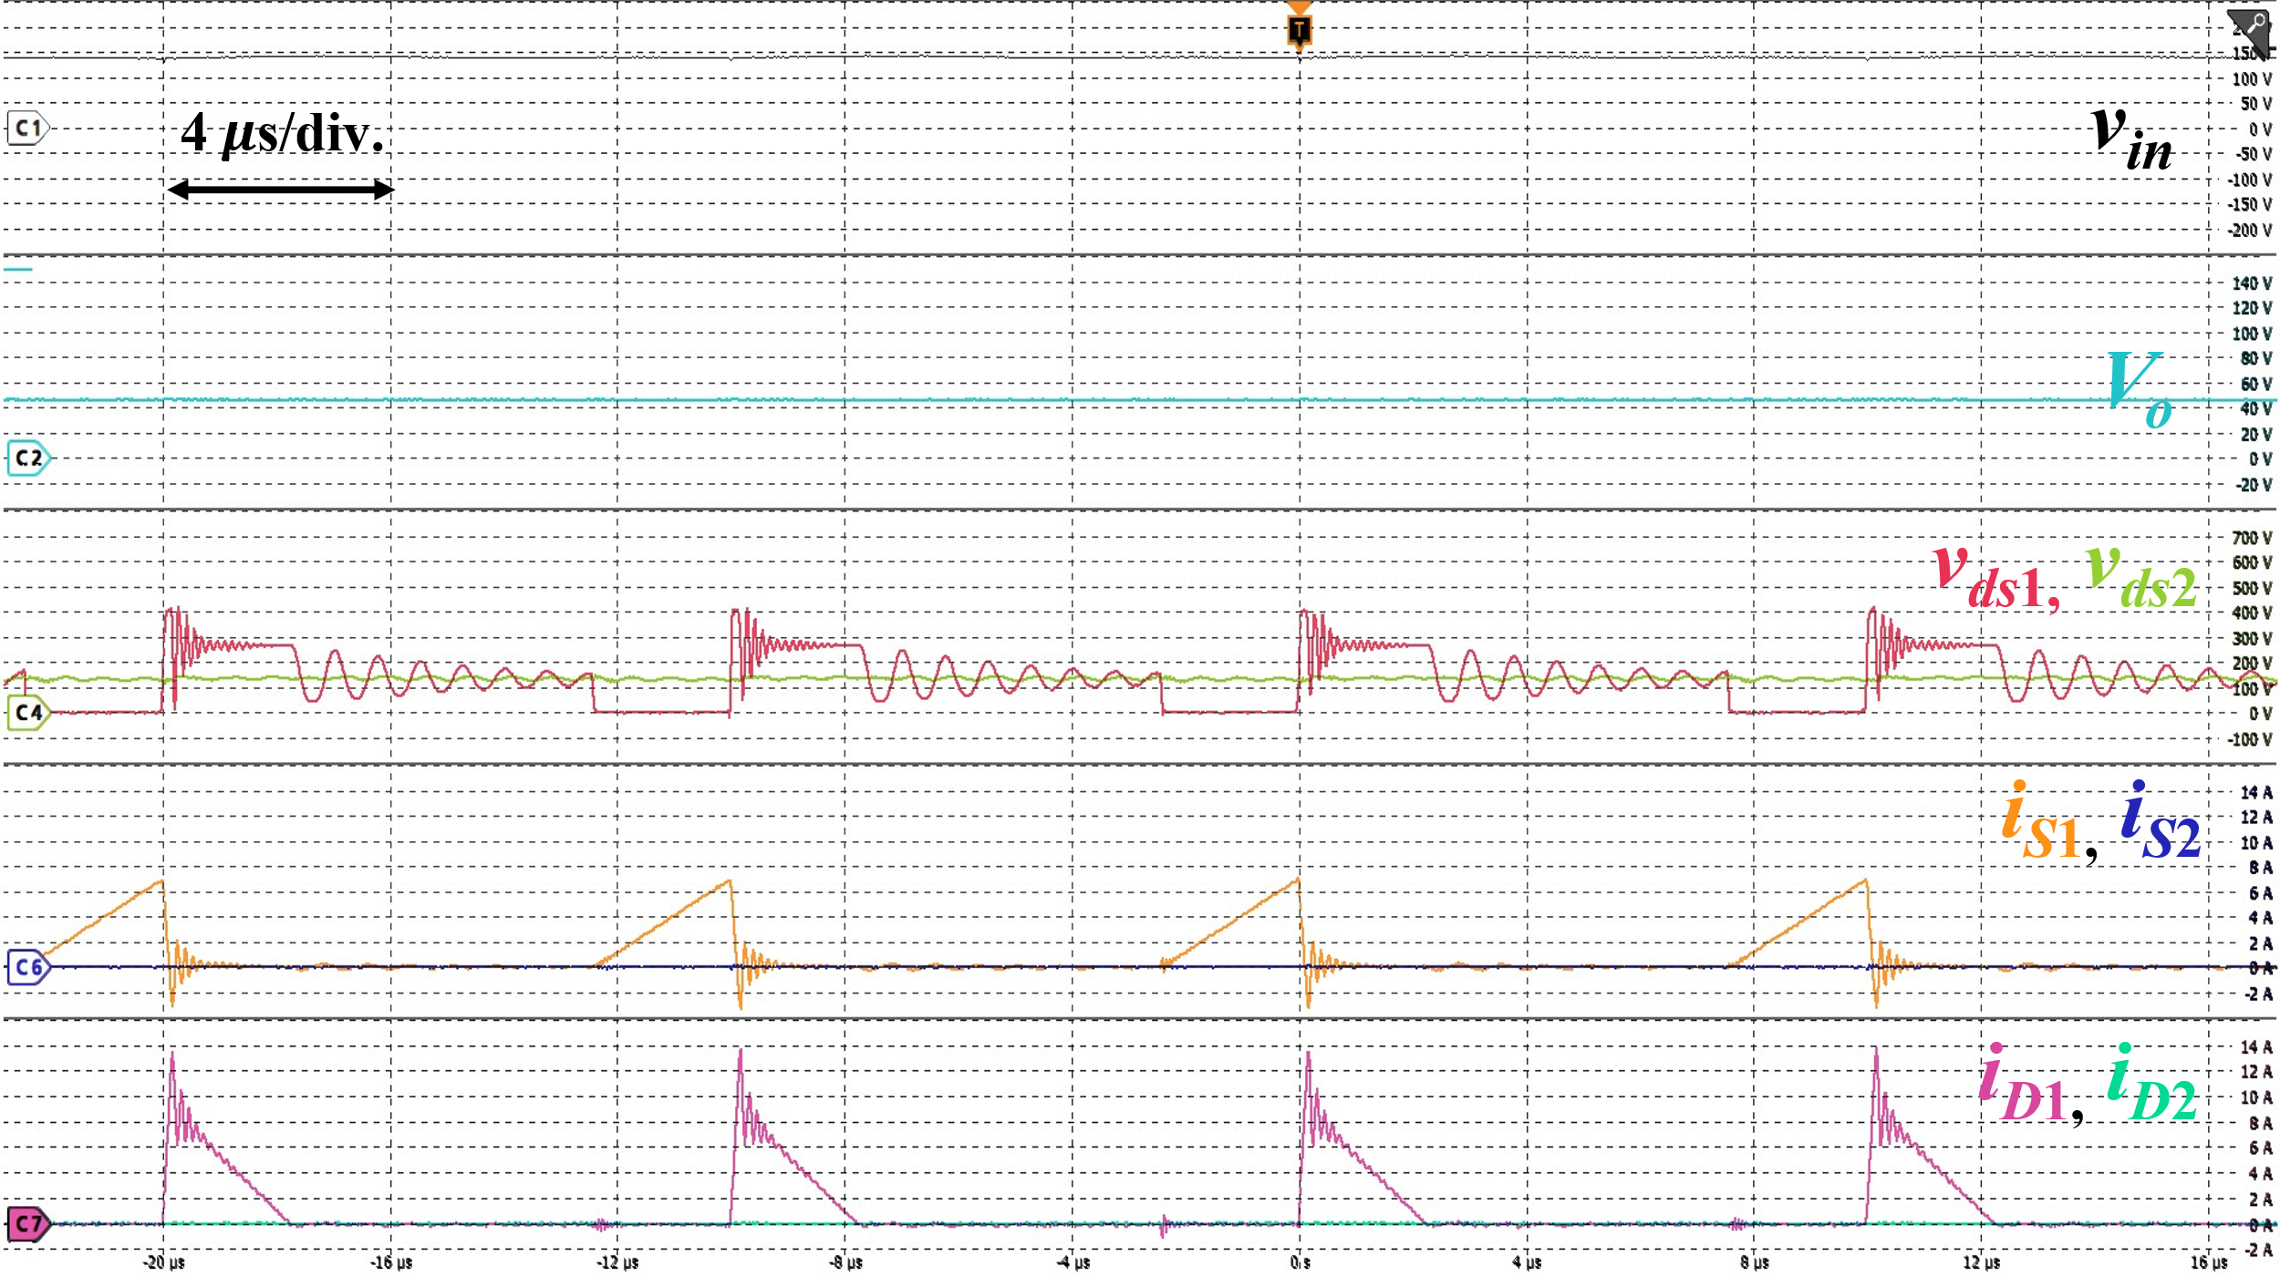  (d)  Fig. 17. Experimental waveforms of the proposed two-phase interleaved flyback rectifier at (a) and (b): 100 W, two-phase AC drive; (c): 240 W, two-phase AC drive; (d): 32.5 W, single-phase AC drive. For (a) and (b): $v_{in}$: 50 V/div., $V_{o}$: 10 V/div., $v_{ds1}$, $v_{ds2}$: 100 V/div., $i_{S1}$, $i_{S2}$: 1 A/div., $i_{D1}$, $i_{D2}$: 5 A/div.; For (c): $v_{in}$: 50 V/div., $V_{o}$: 10 V/div., $v_{ds1}$, $v_{ds2}$: 100 V/div., $i_{S1}$, $i_{S2}$: 2 A/div., $i_{D1}$, $i_{D2}$: 5 A/div.; For (d): $v_{in}$: 50 V/div., $V_{o}$: 20 V/div., $v_{ds1}$, $v_{ds2}$: 100 V/div., $i_{S1}$, $i_{S2}$: 2 A/div., $i_{D1}$, $i_{D2}$: 2 A/div. | (in Section V, Fig. 17)  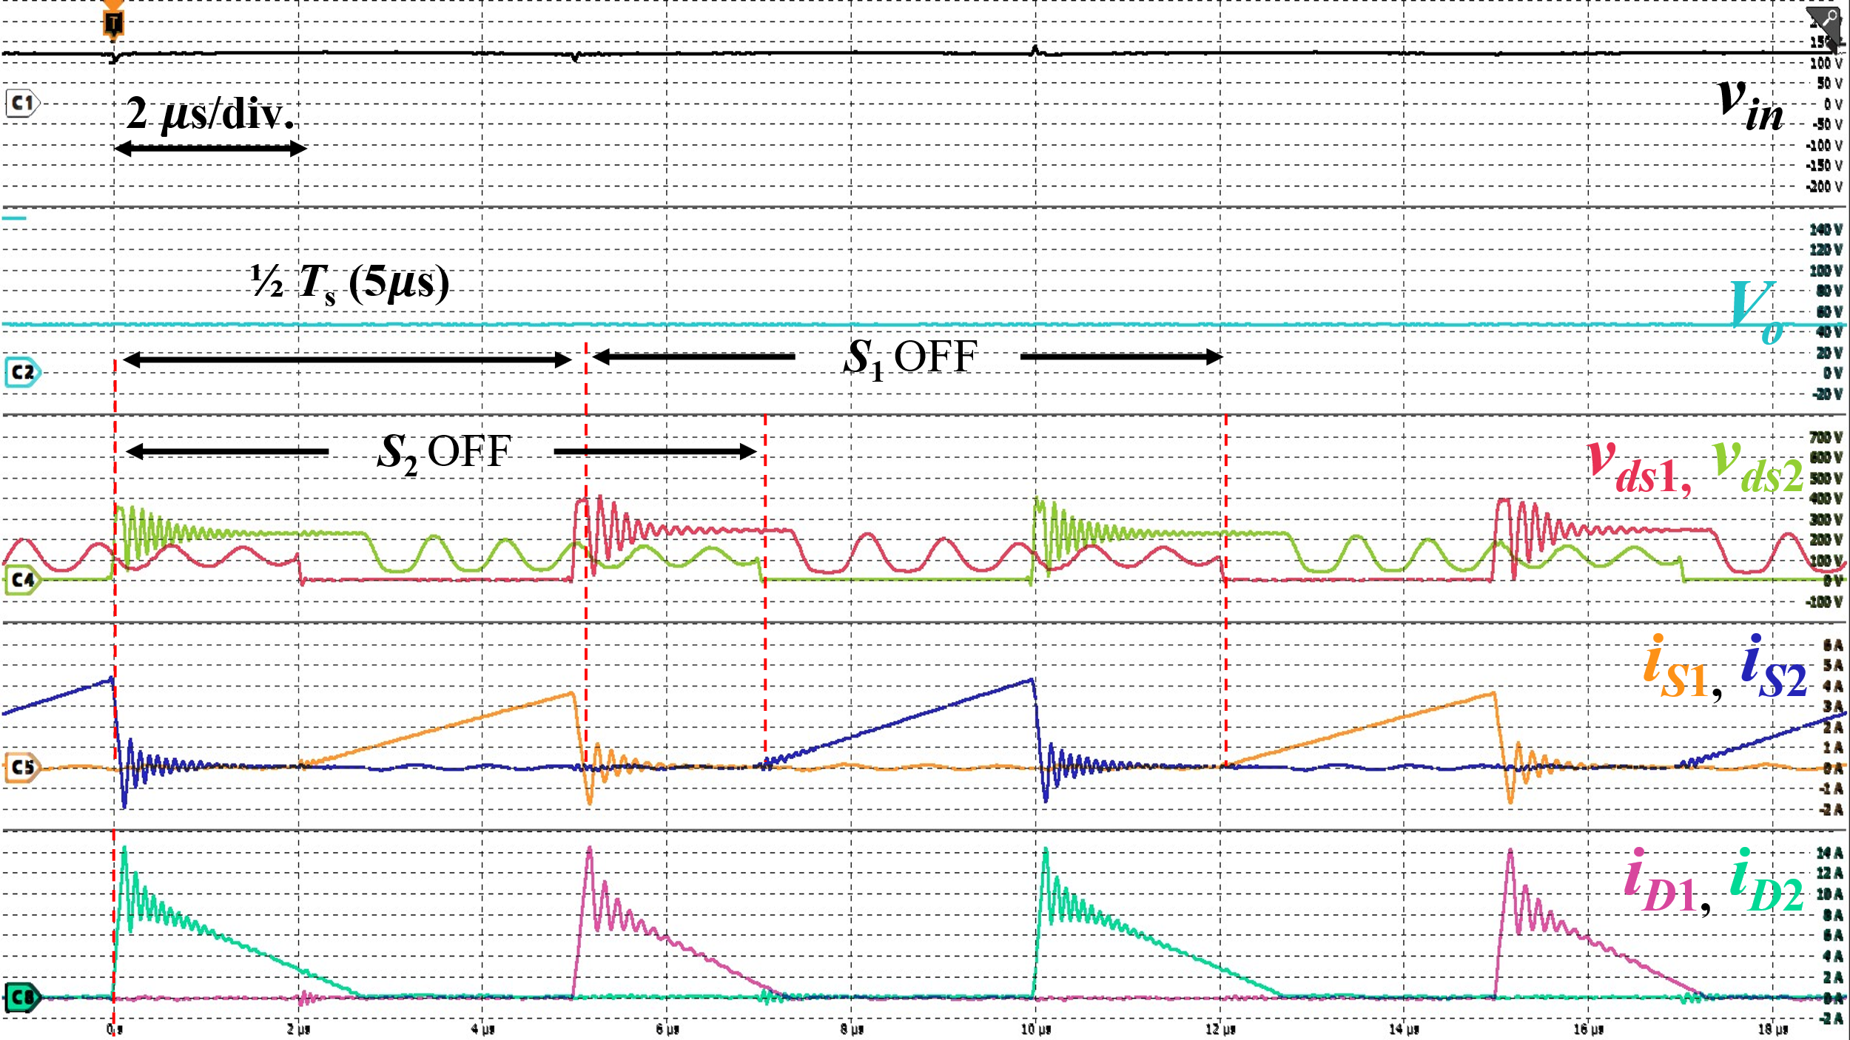  (b)  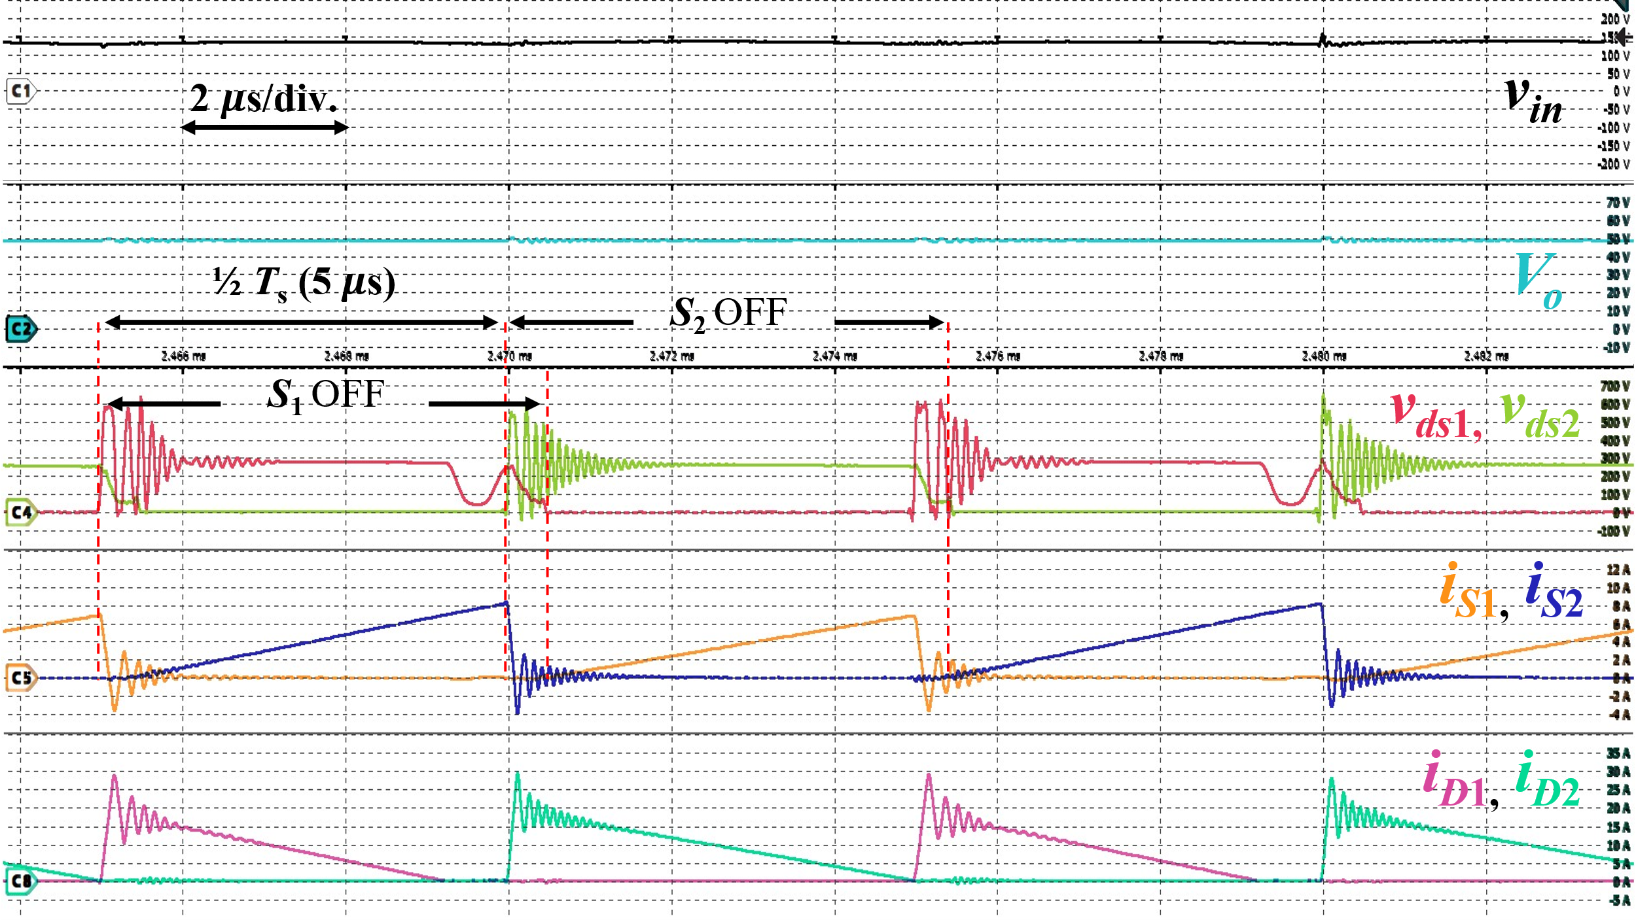  (c)  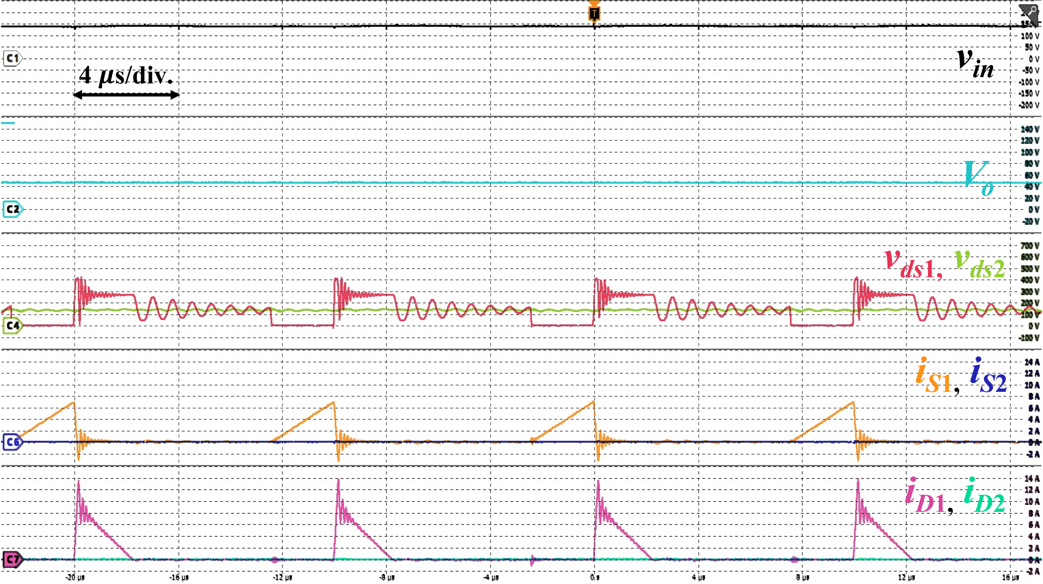  (d)  Fig. 17. Experimental waveforms of the proposed two-phase interleaved flyback rectifier at (a) and (b): 100 W, two-phase AC drive; (c): 240 W, two-phase AC drive; (d): 32.5 W, single-phase AC drive. For (a) and (b): $v_{in}$: 50 V/div., $V_{o}$: 10 V/div., $v_{ds1}$, $v_{ds2}$: 100 V/div., $i_{S1}$, $i_{S2}$: 1 A/div., $i_{D1}$, $i_{D2}$: 5 A/div.; For (c): $v_{in}$: 50 V/div., $V_{o}$: 10 V/div., $v_{ds1}$, $v_{ds2}$: 100 V/div., $i_{S1}$, $i_{S2}$: 2 A/div., $i_{D1}$, $i_{D2}$: 5 A/div.; For (d): $v_{in}$: 50 V/div., $V_{o}$: 20 V/div., $v_{ds1}$, $v_{ds2}$: 100 V/div., $i_{S1}$, $i_{S2}$: 2 A/div., $i_{D1}$, $i_{D2}$: 2 A/div.

To Reviewer 3
We authors appreciate your valuable comments. The revised parts are indicated by red texts in the manuscript.
Comments to the Author
This paper analyzes the design and implementation of an interleaved Flyback converter based on magnetic integration. My comments are as follows:
- The reviewers suggested including efficiency tests and comparing the results with other similar state-of-the-art topologies, but the authors did not adopt this recommendation.
- The efficiency curves provided in the authors' response are difficult to read due to the excessively wide range of the vertical axis. Furthermore, for an interleaved flyback converter, the prototype's efficiency is merely 85%—a figure far too low to meet the requirements for power electronic converters. While component selection certainly plays a significant role, the efficiency should not be this poor; such results suggest a fundamental flaw in the coupled transformer design or indicate that the topology itself may be incapable of achieving high efficiency.

- The paper should present PFC voltage and current waveforms to substantiate the power factor claims. Typically, an uncontrolled rectifier with capacitive filtering yields a power factor of only 0.6–0.7 in the absence of PFC modulation.

We would like to reiterate that the flyback converter is operating in DCM. As we indicated in the paper by theory, the converter will operate naturally in PFC, yielding a high power factor.

To further reinforce this assumption, we present some simulation results at representative operating points for the converter.
- End of the response letter-

